Laptop Market insights

Objective:
The purpose of this Power BI project is to analyze various laptop specifications and understand how features like screen size, CPU, RAM, GPU, and other attributes influence the laptop price and performance.
The main goal is to identify key insights on pricing patterns, performance indicators, and brand comparisons for data-driven decision-making.

Tools Used: Power BI Desktop

Dataset Overview

The dataset contains detailed information about laptops with the following key fields:
• Company
• Type Name
• Inches (Screen Size)
• CPU
• RAM (Cleaned)
• Memory
• GPU
• Operating System (OpSys)
• Weight
• Price
• Resolution Width & Height

Data Cleaning and Transformation (Power Query Editor)

Data was transformed and cleaned in Power Query Editor to ensure accuracy and consistency.

Transformation Steps:
1. Removed unnecessary columns.
2. Split columns – Divided the Memory column into Storage Type and Storage Capacity for better analysis.
3. Extracted new information – Created a GPU Brand column from the GPU field.
4. Cleaned column names – Standardized and renamed columns for clarity.
5. Replaced inconsistent values – Cleaned categorical data such as CPU, OpSys, and Memory for uniformity.
6. Removed nulls and duplicates – Ensured data quality.
7. Added new calculated columns and measures – For further insights such as PPI using DAX.

DAX Measures

Created custom measures in Power BI Data View to support dynamic KPI cards and visuals:
• Average Price = AVERAGE(Laptop[Price])
• Highest Price = MAX(Laptop[Price])
• Average PPI = AVERAGE(Laptop[PPI])

Dashboard Design (Single-Page Layout)
The dashboard is designed on one single page, following a clean, minimal, and professional layout for easy interpretation.
Dashboard Design:
The final Laptop Market Insights Dashboard was designed to provide a clear and professional overview of key laptop specifications and pricing insights. The layout was created in a single interactive page using slicers, KPI cards, and charts for better usability and storytelling.
Dashboard Components:
KPI Cards:
• Average PPI: Displays the average pixels per inch (PPI) across all
laptop models.
• Average Price: Shows the mean laptop price in the dataset.
• Highest Price: Highlights the most expensive laptop model available.
Visualizations:
1.Donut Chart – Laptop Market Share by Company:
Represents each company’s share in the overall laptop market, helping identify top-performing brands such as Lenovo, HP, and Dell.
2. Clustered Column Chart – Average Price by Brand:
Compares the average laptop prices across various brands to analyze market
positioning and pricing strategy.
3. Clustered Bar Chart – Average Price by GPU Brand:
Evaluates how GPU brands (AMD, Intel, Nvidia) impact the overall laptop pricing.
4. Clustered Column Chart – Average Price by RAM Capacity:
Examines how different RAM capacities affect average laptop prices,
helping understand configuration-based price variation.
• Slicers (Filters):
• Company, Operating System, CPU Type, and GPU Brand:
Allow users to interactively filter the data to view insights based on selected brands or specification
Design Approach:
A minimalist, professional layout was followed using consistent font sizes, alignment, and spacing. All visuals are color-coordinated with a clean background and strong header to enhance readability and visual appeal.

Dashboard Design
The final Laptop Market Insights Dashboard was designed to provide a clear and professional overview of key laptop specifications and pricing insights. The layout was created in a single interactive page using slicers, KPI cards, and charts for better usability and storytelling.

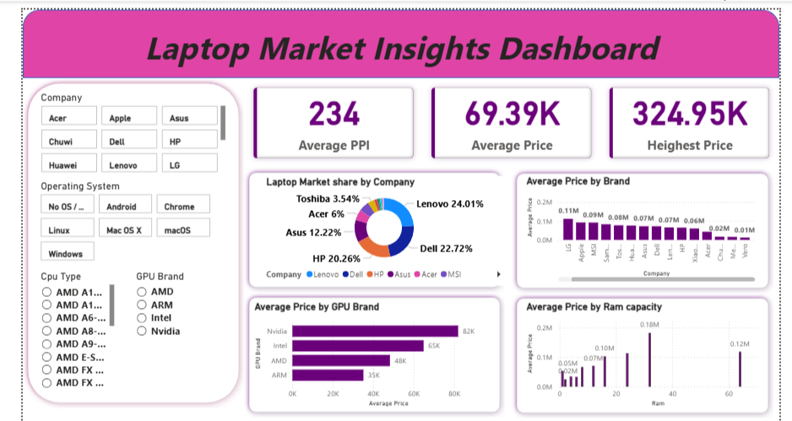

Insights & Findings
• Brand Comparison: Premium brands have noticeably higher average prices despite similar hardware.
• Performance Indicator: Laptops with higher PPI and stronger GPU configurations command higher prices.
• Market Range: Most laptops fall within mid-price ranges, showing strong demand for balanced performance devices.

Conclusion

This project demonstrates the complete Power BI workflow — from data transformation and cleaning in Power Query to visual analytics using DAX and interactive dashboards.
It reflects proficiency in:
• Data Preparation
• DAX Calculations
• Dashboard Design and Storytelling

The final dashboard presents a professional, interactive summary of laptop specifications and pricing insights.

